https://www.linkedin.com/posts/attonrasquinha_microsoftfabric-dataplatform-businessintelligence-activity-7189712394825220096-SVNW?utm_source=share&utm_medium=member_desktop

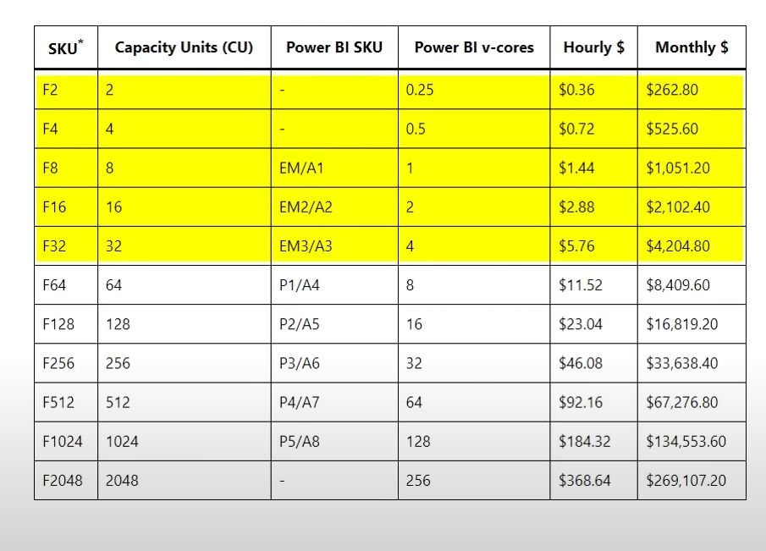

How much does it cost and how does licensing work? I got you covered. Have a read :)  
  
✅ Hierarchy in Fabric: Tenant --> Capacities (One or more) --> Workspaces (One or more under a capacity) --> Items (Lakehouse, Warehouse, Semantic Models) --> Objects (Tables, Views, Stored Procedures & so on)  
  
✅ If you have a PBI Pro User License/ PBI Embedded Capacity / Premium Per user, then you cannot create fabric items. You will need to have a fabric capacity along with the license.  
  
✅ SKU's that are lesser than F64 requires a PBI pro/ PPU Account license to consume Power BI Content. F64 is the minimum SKU needed for Power BI sharing with free accounts meaning without having a PBI license.  
  
✅ Premium capacity costs $5K/per month, Premium Per User costs $20/per month and PBI Pro costs $10/per month.

✅ If your organization needs >500 licenses than go for Premium Capacity. F SKUs are charged per second of usage  
  
✅ Some of the Premium features of PPU account are Direct Query, Dataflows, Deployment pipelines, Data marts and 48 refreshes per day.   
  
✅ For Users <500, You can downgrade your license to PBI Pro and purchase a Fabric capacity (min F2) to get all the features except 48 refreshes per day which will save you some $'s but reasonable security options like Managed Private endpoints start from F64 and above.  
  
✅ You would also incur OneLake storage cost comparable to Azure ADLS which is $0.023 per GB per month.